PRACTICAL FILE

**SESSION: 2023-24**

**Compiler Design Lab**

**(CIC 351)**

**III Year, V Sem**

# Submitted to: Submitted by:

**Name:** Dr Seema Verma **Name:** Adityan Verma

**Designation:** Professor **Enrollment No.** 07818002721

**INDEX**

|  |  |  |  |  |
| --- | --- | --- | --- | --- |
| **S.NO.** | **PROGRAM NAME** | **DATE OF EXPERIMENT** | **DATE OF SUBMISSION** | **SIGN.** |
| 1 | About **LEX/YACC** of compiler writing |  |  |  |
| 2 | Write a program to check whether a **string** belong to the grammar or not. |  |  |  |
| 3 | Write a program to check whether a string include **keyword** or not. |  |  |  |
| 4 | Write a program to remove **Left Recursion** from a grammar |  |  |  |
| 5 | Write a program to perform **Left Factoring** on a grammar. |  |  |  |
| 6 | Write a program to show all the **operations of a stack**. |  |  |  |
| 7 | Write a program to find out the **leading or FOLLOW** of the non-terminal in a grammar. |  |  |  |
| 8 | Write a program to Implement **Shift Reduce parsing** for a String. |  |  |  |
| 9 | Write a program to find out the **FIRST** of the Non-terminals in a grammar. |  |  |  |
| 10 | Write a program to check whether a grammar is **operator precedence**. |  |  |  |

**Experiment-1**

**AIM:** About **LEX/YACC** of compiler writing.

**Lexical Analysis**

It is the first step of compiler design; it takes the input as a stream of characters and gives the output as tokens also known as tokenization. The tokens can be classified into identifiers, Separators, Keywords, Operators, Constant and Special Characters.

It has three phases:

1. **Tokenization:** It takes the stream of characters and converts it into tokens.
2. **Error Messages:** It gives errors related to lexical analysis such as exceeding length, unmatched string, etc.
3. **Eliminate Comments:** Eliminates all the spaces, blank spaces, new lines, and indentations.

**Lex**

Lex is a tool or a computer program that generates Lexical Analyzers (converts the stream of characters into tokens). The Lex tool itself is a compiler. The Lex compiler takes the input and transforms that input into input patterns. It is commonly used with [YACC](https://www.geeksforgeeks.org/introduction-to-yacc/)(Yet Another Compiler Compiler). It was written by Mike Lesk and Eric Schmidt.

### Function of Lex

1. In the first step the source code which is in the Lex language having the file name ‘File.l’ gives as input to the Lex Compiler commonly known as Lex to get the output as lex.yy.c.
2. After that, the output lex.yy.c will be used as input to the C compiler which gives the output in the form of an ‘a.out’ file, and finally, the output file a.out will take the stream of character and generates tokens as output.

### Lex File Format

A Lex program consists of three parts and is separated by %% delimiters: -

**Declarations:**

%%

Translation rules

%%

Auxiliary procedures

**Declarations:** The declarations include declarations of variables.

**Transition rules:** These rules consist of Pattern and Action.

**Auxiliary procedures:** The Auxiliary section holds auxiliary functions used in the actions.

**For example:**

**declaration**

number[0-9]

%%

**translation**

if {return (IF);}

%%

**auxiliary function**

int numberSum()

**YACC**

* YACC stands for Yet Another Compiler Compiler.
* YACC provides a tool to produce a parser for a given grammar.
* YACC is a program designed to compile a LALR (1) grammar.
* It is used to produce the source code of the syntactic analyzer of the language produced by LALR (1) grammar.
* The input of YACC is the rule or grammar and the output is a C program.

These are some points about YACC:

**Input: A CFG- file.y**

**Output: A parser y.tab.c (yacc)**

* The output file "file.output" contains the parsing tables.
* The file "file.tab.h" contains declarations.
* The parser called the yyparse ().
* Parser expects to use a function called yylex () to get tokens.

**Experiment-2**

**AIM:** Write a program to check whether a **string** belong to the grammar or not.

**Program:**

#include <stdio.h>

#include <string.h>

int isBelongToGrammar(char *str) {

int len = strlen(str);

int i = 0;

while (i < len) {

if (str[i] == 'a') {

i++;

} else if (str[i] == 'b') {

i++;

while (i < len && str[i] == 'b') {

i++;

}

} else {

return 0;

}

}

// Check if the string ends in 'ab'

if (i == len || (i == len - 1 && str[i] == 'a')) {

return 1;

}

return 0;

}

int main() {

char input[100];

printf("\nThe grammar is :- \n S -> aS \n S -> Sb \n S -> ab\n\n");

printf("Enter a string: ");

scanf("%s", input);

if (isBelongToGrammar(input)) {

printf("String belongs to the grammar.\n\n");

} else {

printf("String does not belong to the grammar.\n\n");

}

return 0;

}

**Output:**

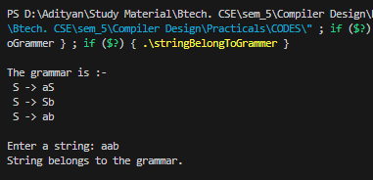

**Experiment-3**

**AIM:** Write a program to check whether a string include **keyword** or not.

**Program:**

#include <stdio.h>

#include <string.h>

int containsKeyword(const char *str, const char *keyword) {

if (strstr(str, keyword) != NULL) {

return 1; // Keyword found in the string

}

return 0; // Keyword not found in the string

}

int main() {

char input[500];

char keyword[20];

printf("\nEnter a string: ");

fgets(input, sizeof(input), stdin);

input[strcspn(input, "\n")] = '\0'; // Remove newline from fgets input

printf("Enter the keyword to check: ");

fgets(keyword, sizeof(keyword), stdin);

keyword[strcspn(keyword, "\n")] = '\0'; // Remove newline from fgets input

if (containsKeyword(input, keyword)) {

printf("\nThe string contains the keyword '%s'.\n", keyword);

} else {

printf("\nThe string does not contain the keyword '%s'.\n", keyword);

}

printf("\n");

return 0;

}

**Output:**

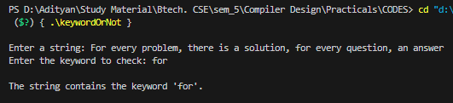

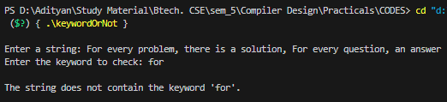

**Experiment-4**

**AIM:** Write a program to remove **Left Recursion** from a grammar.

**Program:**

#include <stdio.h>

#include <string.h>

#define SIZE 10

int main()

{

char non_terminal;

char beta, alpha;

int num;

char production[10][SIZE];

int index = 3;

printf("\nEnter Number of Production : ");

scanf("%d", &num);

printf("Enter the grammar :-\n");

for (int i = 0; i < num; i++)

{

scanf("%s", production[i]);

}

for (int i = 0; i < num; i++)

{

printf("\nGRAMMAR --> %s", production[i]);

non_terminal = production[i][0];

if (non_terminal == production[i][index])

{

alpha = production[i][index + 1];

printf(" is left recursive.\n\n");

while (production[i][index] != 0 && production[i][index] != '|')

index++;

if (production[i][index] != 0)

{

beta = production[i][index + 1];

printf("Grammar without left recursion:\n");

printf("%c->%c%c\'", non_terminal, beta, non_terminal);

printf("\n%c\'->%c%c\'|E\n", non_terminal, alpha, non_terminal);

}

else

printf(" can't be reduced\n");

}

else

printf(" is not left recursive.\n");

index = 3;

}

printf("\n");

return 0;

}

**Output:**

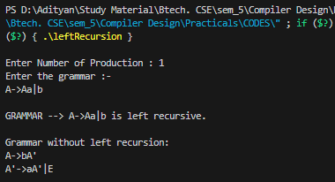

**Experiment-5**

**AIM:** Write a program to perform **Left Factoring** on a grammar

**Program:**

#include <stdio.h>

#include <string.h>

int main()

{

char gram[20], part1[20], part2[20], modifiedGram[20], newGram[20], tempGram[20];

int i, j = 0, k = 0, l = 0, pos;

printf("\nEnter Production : A->");

gets(gram);

for (i = 0; gram[i] != '|'; i++, j++)

part1[j] = gram[i];

part1[j] = '\0';

for (j = ++i, i = 0; gram[j] != '\0'; j++, i++)

part2[i] = gram[j];

part2[i] = '\0';

for (i = 0; i < strlen(part1) || i < strlen(part2); i++) {

if (part1[i] == part2[i]) {

modifiedGram[k] = part1[i];

k++;

pos = i + 1;

}

}

for (i = pos, j = 0; part1[i] != '\0'; i++, j++) {

newGram[j] = part1[i];

}

newGram[j++] = '|';

for (i = pos; part2[i] != '\0'; i++, j++) {

newGram[j] = part2[i];

}

modifiedGram[k] = 'X';

modifiedGram[++k] = '\0';

newGram[j] = '\0';

printf("\nGrammar Without Left Factoring :-\n");

printf(" A->%s", modifiedGram);

printf("\n X->%s\n", newGram);

printf("\n");

return 0;

}

**Output:**

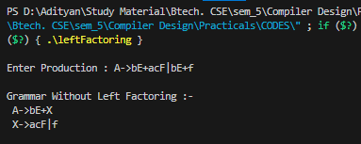

**Experiment-6**

**AIM:** Write a program to show all the **operations of a stack. Program:**

#include <stdio.h>

#include <stdlib.h>

#include <stdbool.h>

#define STACK_CAPACITY 100

struct Stack {

int top;

unsigned capacity;

int *array;

};

struct Stack *createStack(unsigned capacity) {

struct Stack *stack = (struct Stack *)malloc(sizeof(struct Stack));

if (stack == NULL) {

printf("Memory allocation failed.\n");

return NULL;

}

stack->capacity = capacity;

stack->top = -1;

stack->array = (int *)malloc(stack->capacity * sizeof(int));

if (stack->array == NULL) {

printf("Memory allocation failed.\n");

free(stack);

return NULL;

}

return stack;

}

bool isFull(struct Stack *stack) {

return stack->top == stack->capacity - 1;

}

bool isEmpty(struct Stack *stack) {

return stack->top == -1;

}

void push(struct Stack *stack, int item) {

if (isFull(stack)) {

printf("Stack overflow, can't push %d\n", item);

return;

}

stack->array[++stack->top] = item;

printf("%d pushed to stack\n", item);

}

int pop(struct Stack *stack) {

if (isEmpty(stack)) {

printf("Stack underflow, can't pop\n");

return -1; // Returning an arbitrary value to indicate underflow

}

int item = stack->array[stack->top--];

printf("%d popped from stack\n", item);

return item;

}

int peek(struct Stack *stack) {

if (isEmpty(stack)) {

printf("Stack is empty, no top element\n");

return -1; // Returning an arbitrary value to indicate empty stack

}

return stack->array[stack->top];

}

void freeStack(struct Stack *stack) {

free(stack->array);

free(stack);

printf("Stack memory freed\n");

}

int main() {

struct Stack *stack = createStack(STACK_CAPACITY);

if (stack == NULL) {

return -1; // Exiting due to memory allocation failure

}

printf("\n");

push(stack, 10);

push(stack, 20);

push(stack, 30);

pop(stack);

pop(stack);

pop(stack);

pop(stack); // Trying to pop from an empty stack

freeStack(stack);

printf("\n");

return 0;

}

**Output:**

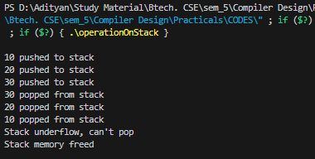

**Experiment-7**

**AIM:** Write a program to find out the leading or **FOLLOW** of the non-terminals in a grammar.

**Program:**

#include <ctype.h>

#include <stdio.h>

#include <string.h>

// Functions to calculate Follow

void followfirst(char, int, int);

void follow(char c);

// Function to calculate First

void findfirst(char, int, int);

int count, n = 0;

// Stores the final result

// of the First Sets

char calc_first[10][100];

// Stores the final result

// of the Follow Sets

char calc_follow[10][100];

int m = 0;

// Stores the production rules

char production[10][10];

char f[10], first[10];

int k;

char ck;

int e;

int main(int argc, char** argv)

{

int jm = 0;

int km = 0;

int i, choice;

char c, ch;

count = 8;

// The Input grammar

strcpy(production[0], "X=TnS");

strcpy(production[1], "X=Rm");

strcpy(production[2], "T=q");

strcpy(production[3], "T=#");

strcpy(production[4], "S=p");

strcpy(production[5], "S=#");

strcpy(production[6], "R=om");

strcpy(production[7], "R=ST");

int kay;

char done[count];

int ptr = -1;

// Initializing the calc_first array

for (k = 0; k < count; k++) {

for (kay = 0; kay < 100; kay++) {

calc_first[k][kay] = '!';

}

}

int point1 = 0, point2, xxx;

for (k = 0; k < count; k++) {

c = production[k][0];

point2 = 0;

xxx = 0;

// Checking if First of c has

// already been calculated

for (kay = 0; kay <= ptr; kay++)

if (c == done[kay])

xxx = 1;

if (xxx == 1)

continue;

// Function call

findfirst(c, 0, 0);

ptr += 1;

// Adding c to the calculated list

done[ptr] = c;

printf("\n First(%c) = { ", c);

calc_first[point1][point2++] = c;

// Printing the First Sets of the grammar

for (i = 0 + jm; i < n; i++) {

int lark = 0, chk = 0;

for (lark = 0; lark < point2; lark++) {

if (first[i] == calc_first[point1][lark]) {

chk = 1;

break;

}

}

if (chk == 0) {

printf("%c, ", first[i]);

calc_first[point1][point2++] = first[i];

}

}

printf("}\n");

jm = n;

point1++;

}

printf("\n");

printf("-----------------------------------------------"

"\n\n");

char donee[count];

ptr = -1;

// Initializing the calc_follow array

for (k = 0; k < count; k++) {

for (kay = 0; kay < 100; kay++) {

calc_follow[k][kay] = '!';

}

}

point1 = 0;

int land = 0;

for (e = 0; e < count; e++) {

ck = production[e][0];

point2 = 0;

xxx = 0;

// Checking if Follow of ck

// has already been calculated

for (kay = 0; kay <= ptr; kay++)

if (ck == donee[kay])

xxx = 1;

if (xxx == 1)

continue;

land += 1;

// Function call

follow(ck);

ptr += 1;

// Adding ck to the calculated list

donee[ptr] = ck;

printf(" Follow(%c) = { ", ck);

calc_follow[point1][point2++] = ck;

// Printing the Follow Sets of the grammar

for (i = 0 + km; i < m; i++) {

int lark = 0, chk = 0;

for (lark = 0; lark < point2; lark++) {

if (f[i] == calc_follow[point1][lark]) {

chk = 1;

break;

}

}

if (chk == 0) {

printf("%c, ", f[i]);

calc_follow[point1][point2++] = f[i];

}

}

printf(" }\n\n");

km = m;

point1++;

}

}

void follow(char c)

{

int i, j;

// Adding "$" to the follow

// set of the start symbol

if (production[0][0] == c) {

f[m++] = '$';

}

for (i = 0; i < 10; i++) {

for (j = 2; j < 10; j++) {

if (production[i][j] == c) {

if (production[i][j + 1] != '\0') {

// Calculate the first of the next

// Non-Terminal in the production

followfirst(production[i][j + 1], i,

(j + 2));

}

if (production[i][j + 1] == '\0'

&& c != production[i][0]) {

// Calculate the follow of the

// Non-Terminal in the L.H.S. of the

// production

follow(production[i][0]);

}

}

}

}

}

void findfirst(char c, int q1, int q2)

{

int j;

// The case where we

// encounter a Terminal

if (!(isupper(c))) {

first[n++] = c;

}

for (j = 0; j < count; j++) {

if (production[j][0] == c) {

if (production[j][2] == '#') {

if (production[q1][q2] == '\0')

first[n++] = '#';

else if (production[q1][q2] != '\0'

&& (q1 != 0 || q2 != 0)) {

// Recursion to calculate First of New

// Non-Terminal we encounter after

// epsilon

findfirst(production[q1][q2], q1,

(q2 + 1));

}

else

first[n++] = '#';

}

else if (!isupper(production[j][2])) {

first[n++] = production[j][2];

}

else {

// Recursion to calculate First of

// New Non-Terminal we encounter

// at the beginning

findfirst(production[j][2], j, 3);

}

}

}

}

void followfirst(char c, int c1, int c2)

{

int k;

// The case where we encounter

// a Terminal

if (!(isupper(c)))

f[m++] = c;

else {

int i = 0, j = 1;

for (i = 0; i < count; i++) {

if (calc_first[i][0] == c)

break;

}

// Including the First set of the

// Non-Terminal in the Follow of

// the original query

while (calc_first[i][j] != '!') {

if (calc_first[i][j] != '#') {

f[m++] = calc_first[i][j];

}

else {

if (production[c1][c2] == '\0') {

// Case where we reach the

// end of a production

follow(production[c1][0]);

}

else {

// Recursion to the next symbol

// in case we encounter a "#"

followfirst(production[c1][c2], c1,

c2 + 1);

}

}

j++;

}

}

}

**Output:**

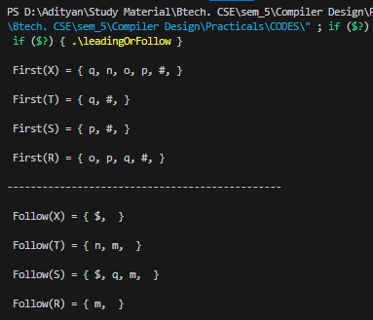

**Experiment-8**

**AIM:** Write a program to Implement **Shift Reduce parsing** for a String.

**Program:**

#include <stdio.h>

#include <stdlib.h>

#include <string.h>

int z = 0, i = 0, j = 0, c = 0;

char a[16], ac[20], stk[15], act[10];

void check() {

strcpy(ac, "REDUCE TO E -> ");

for (z = 0; z < c; z++) {

if (stk[z] == '4') {

printf("%s4", ac);

stk[z] = 'E';

stk[z + 1] = '\0';

printf("\n$%s\t%s$\t", stk, a);

}

}

for (z = 0; z < c - 2; z++) {

if (stk[z] == '2' && stk[z + 1] == 'E' && stk[z + 2] == '2') {

printf("%s2E2", ac);

stk[z] = 'E';

stk[z + 1] = '\0';

stk[z + 2] = '\0';

printf("\n$%s\t%s$\t", stk, a);

i = i - 2;

}

}

for (z = 0; z < c - 2; z++) {

if (stk[z] == '3' && stk[z + 1] == 'E' && stk[z + 2] == '3') {

printf("%s3E3", ac);

stk[z] = 'E';

stk[z + 1] = '\0';

printf("\n$%s\t%s$\t", stk, a);

i = i - 2;

}

}

}

int main() {

printf("\nGRAMMAR is :-\nE->2E2 \nE->3E3 \nE->4\n");

strcpy(a, "32423");

c = strlen(a);

strcpy(act, "SHIFT");

printf("\nstack \t input \t action");

printf("\n$\t%s$\t", a);

for (i = 0; j < c; i++, j++) {

printf("%s", act);

stk[i] = a[j];

stk[i + 1] = '\0';

a[j] = ' ';

printf("\n$%s\t%s$\t", stk, a);

check();

}

check();

if (stk[0] == 'E' && stk[1] == '\0') {

printf("Accept\n");

} else {

printf("Reject\n");

}

printf("\n");

return 0;

}

**Output:**

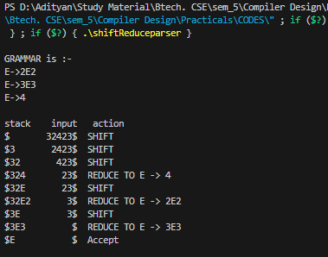

**Experiment-9**

**AIM:** Write a program to find out the **FIRST** of the Non-terminals in a grammar.

**Program:**

#include <stdio.h>

char array[10][20], temp[10];

int c, n;

int fun2(int i, int j, int p[], int key); // Function prototype

void fun(int i, int p[])

{

int j, k, key;

for (j = 2; array[i][j] != '\0'; j++)

{

if (array[i][j - 1] == '/')

{

if (array[i][j] >= 'A' && array[i][j] <= 'Z')

{

key = 0;

fun2(i, j, p, key);

}

else

{

key = 1;

if (fun2(i, j, p, key))

temp[++c] = array[i][j];

if (array[i][j] == '@' && p[0] != -1) // taking '@' as null symbol

{

if (array[p[0]][p[1]] >= 'A' && array[p[0]][p[1]] <= 'Z')

{

key = 0;

fun2(p[0], p[1], p, key);

}

else if (array[p[0]][p[1]] != '/' && array[p[0]][p[1]] != '\0')

{

if (fun2(p[0], p[1], p, key))

temp[++c] = array[p[0]][p[1]];

}

}

}

}

}

}

int fun2(int i, int j, int p[], int key)

{

int k;

if (!key)

{

for (k = 0; k < n; k++)

if (array[i][j] == array[k][0])

break;

p[0] = i;

p[1] = j + 1;

fun(k, p);

return 0;

}

else

{

for (k = 0; k <= c; k++)

{

if (array[i][j] == temp[k])

break;

}

if (k > c)

return 1;

else

return 0;

}

}

int main()

{

int p[2], i, j;

printf("Enter the no. of productions :");

scanf("%d", &n);

printf("Enter the productions :\n");

for (i = 0; i < n; i++)

scanf("%s", array[i]);

for (i = 0; i < n; i++)

{

c = -1, p[0] = -1, p[1] = -1;

fun(i, p);

printf("First(%c) : [ ", array[i][0]);

for (j = 0; j <= c; j++)

printf("%c,", temp[j]);

printf("\b ].\n");

}

return 0;

}

**Output:**

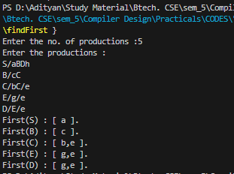

**Experiment-10**

**AIM:** Write a program to check whether a grammar is **operator precedence**.

**Program:**

#include<stdlib.h>

#include<stdio.h>

#include<string.h>

// function f to exit from the loop

// if given condition is not true

void f()

{

printf("Not operator grammar");

exit(0);

}

void main()

{

char grm[20][20], c;

// Here using flag variable,

// considering grammar is not operator grammar

int i, n, j = 2, flag = 0;

printf("\nInput: ");

scanf("%d", &n);

for (i = 0; i < n; i++)

scanf("%s", grm[i]);

for (i = 0; i < n; i++) {

c = grm[i][2];

while (c != '\0') {

if (grm[i][3] == '+' || grm[i][3] == '-'

|| grm[i][3] == '*' || grm[i][3] == '/')

flag = 1;

else {

flag = 0;

f();

}

if (c == '$') {

flag = 0;

f();

}

c = grm[i][++j];

}

}

if (flag == 1)

printf("Operator grammar");

}

**Output:**

